Enterprise Financial Intelligence Dashboard
Power BI Project Documentation

1. What This Project Is
Think of this Power BI file as a digital control room for the company's money. Instead of a finance team member digging through dozens of spreadsheets every month, this report pulls everything into one place — revenue, costs, profit, cash, department spending, headcount, and even "what if" forecasts — and lets anyone with access explore it by clicking dropdown filters instead of writing formulas.
It's built the way real companies build finance systems: raw transactions and numbers sit in the background (called "fact tables"), and clean lookup lists like Department, Region, Account, and Date sit alongside them so everything can be sliced and diced consistently. On top of that sits five report pages, each answering a different everyday question a finance person or manager might ask.

1.1 What Problems It Solves
- "How is the company doing overall this year?" → Executive Summary page
- "What does our income statement look like for a specific month, region or department?" → Dynamic Profit & Loss Statement page
- "Which departments are spending the most, and are they within budget?" → Department Performance page
- "Do we have enough cash coming in to cover what's going out?" → Cash Flow Dashboard page
- "What happens to our numbers if tax rates rise, growth slows, or costs inflate?" → Scenario & Forecasting page

1.2 Who Uses It
- CFOs and Finance Directors — for the big-picture health check and forecasting.
- FP&A Analysts — for detailed P&L review and budget variance tracking.
- Department Heads — to see their own team's cost, headcount and budget performance.
- Regional Managers — through built-in security, they only see the data for their own region/department (more on this in Section 5).

2. Dashboard Page Structure
The report has five tabs. Each one is designed to be read top to bottom: big headline numbers first, then charts that explain the "why" behind those numbers.

2.1 Executive Summary
This is the page a CEO or board member would open first. It answers the question: is the business healthy?
Filters at the top: Year, Region, Department, Entity — change any of these and every number and chart updates instantly.
Headline numbers you'll see:
Number | What it means
Revenue ($12.63bn) | Total money earned from sales/business activity
EBITDA ($5.68bn) | Profit before interest, tax, depreciation and amortization — a clean view of core operating performance
Net Profit ($4.53bn) | What's actually left over after every expense is paid
Net Margin % (35.90%) | Out of every dollar earned, how many cents turn into profit
Free Cash Flow (-$248.06M) | Cash left after running the business and paying for equipment/investments — shown in brackets because it's currently negative

Charts on this page:
- Revenue Trend (YoY) — a line for each year (2022-2025) so you can see, month by month, whether this year is doing better than last year.
- Expenses Breakdown by Category — a donut showing where the money is going (COGS ~35%, Operating Expense ~50%, plus Depreciation, Interest, Tax and Other Income).
- Budget vs Actual Variance — bars showing how far actual spending strayed from what was budgeted, month by month.
- Cash Flow Each Year — a line per year showing how free cash flow moves across the months, helpful for spotting recurring cash-tight periods.

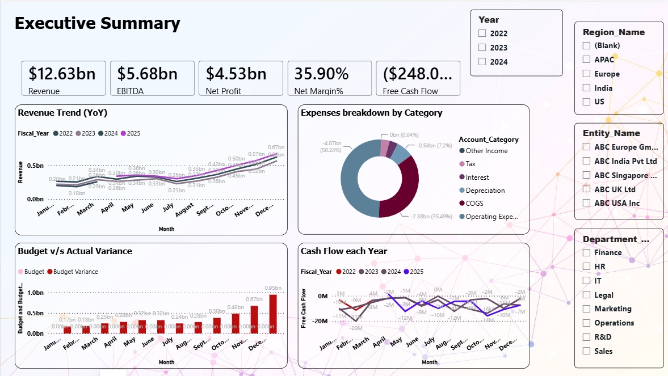

2.2 Dynamic Profit & Loss Statement
This page is essentially a live income statement. Instead of waiting for accounting to send a static PDF, anyone can pick a Fiscal Year, Month, Region, and Department and instantly see that specific slice of the P&L.
Headline numbers: Revenue, Gross Profit, EBITDA, Net Profit, Gross Margin %, Net Margin % — all recalculated for whatever filters are selected.
The table listing every P&L line (Revenue, COGS, Gross Profit, Operating Expense, EBITDA, Net Profit) with three columns side by side: what actually happened (Actual), what was planned (Budget), and the gap between them (Variance and Variance %). Small arrows next to each number turn green when things are going well and red when they're not — so you don't even need to read the numbers to know where to look first.
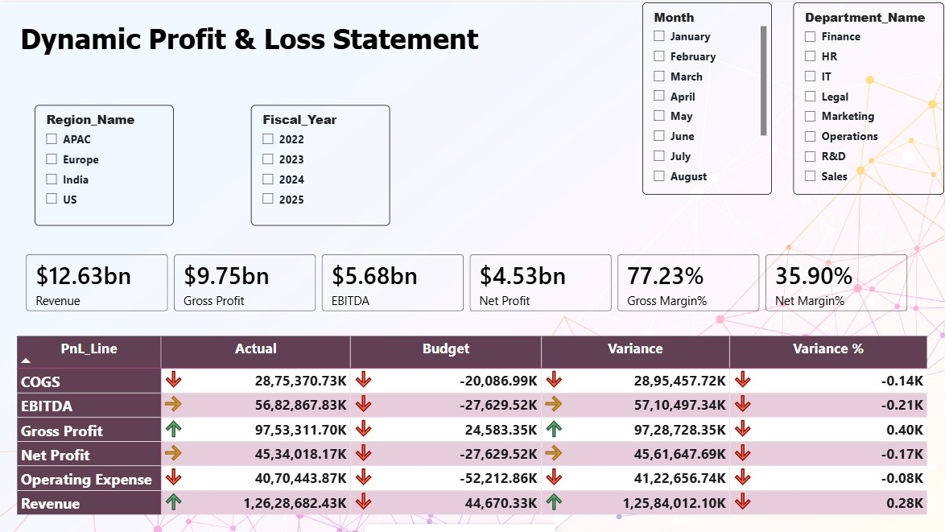

2.3 Department Performance
This page zooms into the 8 departments (Sales, Marketing, Legal, Operations, IT, Finance, R&D, HR) to answer: who's spending what, and is it paying off?
Headline numbers: Total Departments (8), Total Employees (25K), Total Salary Cost ($178.34M), Total CapEx (-$280.49M).
Charts on this page:
- Department Profit — compares Revenue and EBITDA side by side for each department, so you can see which teams generate the most value.
- Headcount Cost Analysis — green bars show monthly salary cost, a blue line tracks headcount over the same months — useful for checking if payroll is growing faster than the team is.
- Total CapEx by Project — a treemap (blocks sized by spend) showing which capital projects (ERP Upgrade, Warehouse Automation, Fleet Acquisition, New Plant Setup, etc.) are eating up the capital budget.
- Actual Expense vs Budget — bars comparing what each department actually spent against what it was allowed to spend.
- Contribution Margin by Department — ranks departments from most to least profitable after variable costs are removed.

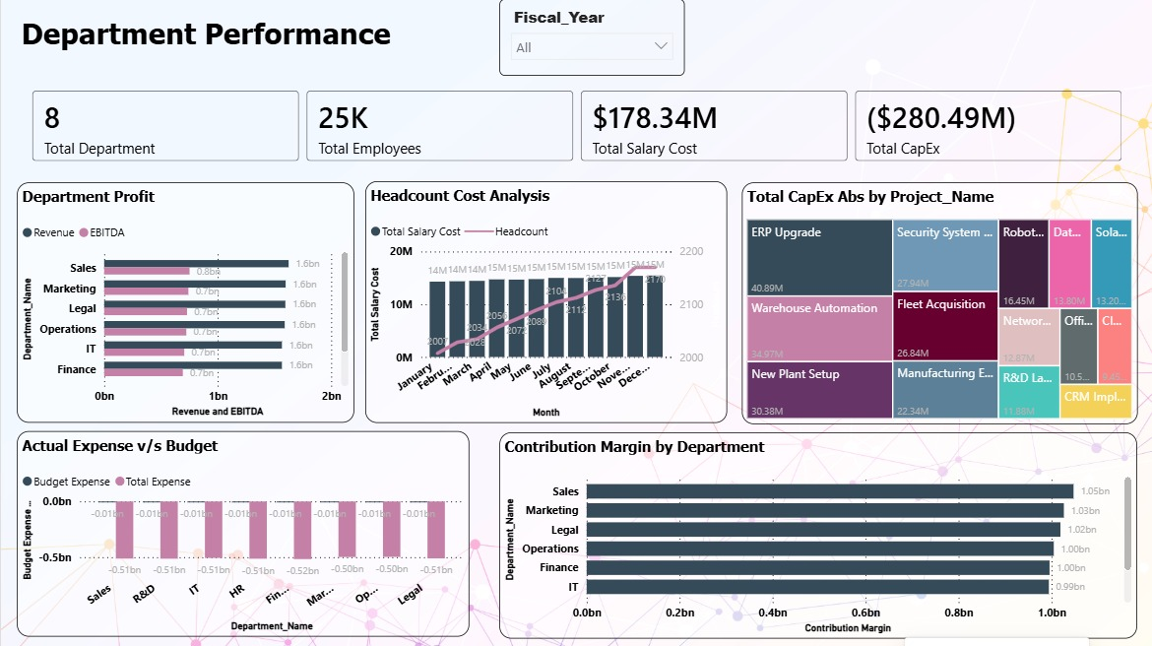

2.4 Cash Flow Dashboard
Profit on paper doesn't always mean cash in the bank. This page tracks the actual movement of cash in and out of the business.
Filters: Fiscal Year, Fiscal Quarter, Region, Department, Account Category.
Headline numbers: Finance Cash Flow, Free Cash Flow, Investing Cash Flow, Net Cash Flow, Operating Cash Flow.
Charts on this page:
- Cash Flow Waterfall — starts at Opening Cash, adds Operating cash, subtracts what went to Investing and Financing activities, and lands on Closing Cash — like watching a bank balance change step by step.
- Net Profit by Month Each Year — four lines (Operating, Investing, Financing, Net Cash Flow) plotted across the months, making it easy to spot unusual spikes or dips (for example, a sharp dip in March).

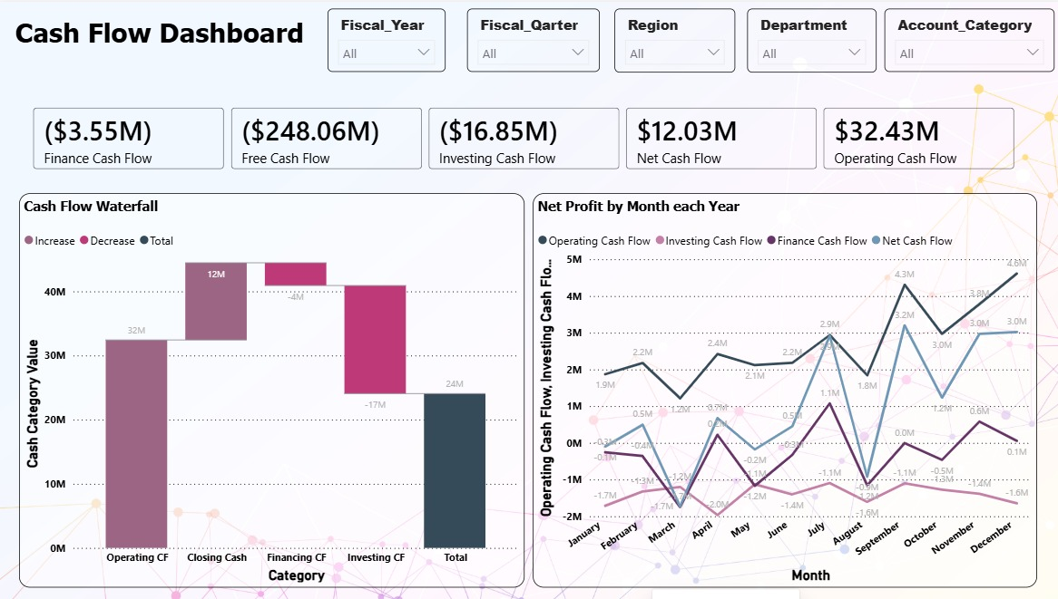

2.5 Scenario & Forecasting ("What If?")
This is the most interactive page. Instead of just looking backward, it lets you test the future. Three sliders let you type in assumptions:
- "If we increase the tax rate by..." (e.g. 15%)
- "If we change revenue growth by..." (e.g. 26%)
- "If we raise expense inflation by..." (e.g. 16%)
As soon as you move a slider, four numbers instantly recalculate: Scenario Revenue, Scenario EBITDA, Scenario Net Profit, and Scenario Cash Flow — plus four charts comparing the original numbers against the new "what if" numbers, year by year and quarter by quarter. This is exactly the kind of tool a CFO would use in a budget planning meeting or board discussion, without needing a separate Excel model.
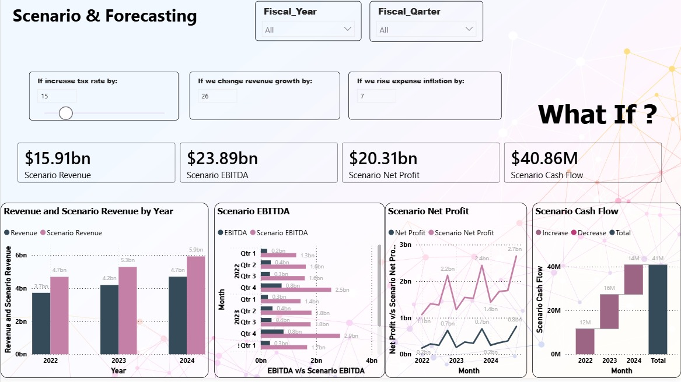

3. How the Data Is Organized (The Data Model)
Behind every chart in this report sits a proper data model — the same approach professional finance systems use. In simple terms, there are two types of tables:
- Fact tables — the raw numbers: every transaction, every budget line, every cash movement, every headcount record, every capital expense.
- Dimension tables — the clean lookup lists that describe those numbers: which Department, which Region, which Account, which Date, which Entity.
This separation is what makes the filters on every page work instantly and consistently — change "Region" once, and every fact table that's connected to Region updates together.

3.1 The Fact Tables (Where the Numbers Live)
Table | What it stores | Fields
Fact_GL_Transactions | Every general ledger transaction — the core source for revenue, cost and P&L numbers | Account_ID, Amount, Cost_Center, Currency, Date, Department_ID, Entity_ID, Journal_Type, Region_ID, Transaction_ID
Fact_Budget | The planned/budgeted amount for each account, department and date, including scenario tagging | Account_ID, Budget_Amount, Date, Department_ID, Scenario
Fact_CashFlow | Cash movements used to build the Cash Flow Dashboard | Amount, Cash_Type, Date
Fact_CapEx | Capital expenditure by project | CapEx_Amount, Date, Department_ID, Project_Name
Fact_Headcount | Monthly employee count and salary cost by department | Date, Department_ID, Employee_Count, Salary_Cost

3.2 The Dimension Tables (The Lookup Lists)
Table | What it describes | Fields
Dim_Date | A full calendar table used to filter everything by time | Date, Day_of_Week, Fiscal_Quarter, Fiscal_Year, Is_Weekend, Month, Month_Number, Quarter, Week_Number, Year
Dim_Department | The 8 departments in the company | Cost_Center, Department_Head, Department_ID, Department_Name
Dim_Account | The chart of accounts used to build the P&L | Account_Category, Account_ID, Account_Name, Account_Type, PnL_Order
Dim_Region | The geographic regions the business operates in | Region_Head, Region_ID, Region_Name
Dim_Entity | The legal entities/subsidiaries in the group | Entity_Country, Entity_Currency, Entity_ID, Entity_Name
Dim_UserSecurity | Controls who can see what (used for security, not shown on report pages) | Access_Level, Department_ID, Region_ID, User_Email

3.3 How the Tables Connect
Picture it like a star with a table in the middle and lookup tables branching off it. Here's how each fact table connects to its lookup tables:
- Fact_GL_Transactions connects to Dim_Date, Dim_Account, Dim_Department, Dim_Region and Dim_Entity — this is the busiest table, since it feeds the P&L and Executive Summary pages.
- Fact_Budget connects to Dim_Date, Dim_Account and Dim_Department — this is what powers every "Budget vs Actual" comparison.
- Fact_CapEx connects to Dim_Date and Dim_Department — powers the Department Performance CapEx treemap.
- Fact_Headcount connects to Dim_Date and Dim_Department — powers the Headcount Cost Analysis chart.
- Fact_CashFlow connects to Dim_Date only — it stores cash movements independently of department/region breakdowns.
- Dim_UserSecurity connects to Dim_Department and Dim_Region — it doesn't feed any chart directly; instead, it's used behind the scenes to control what each logged-in user is allowed to see.
Every one of these connections is a "one-to-many" relationship — one row in a lookup table (say, one Department) can relate to many rows in a fact table (many transactions for that department). This is the standard, correct way to build a fast, reliable Power BI model — often called a star schema.
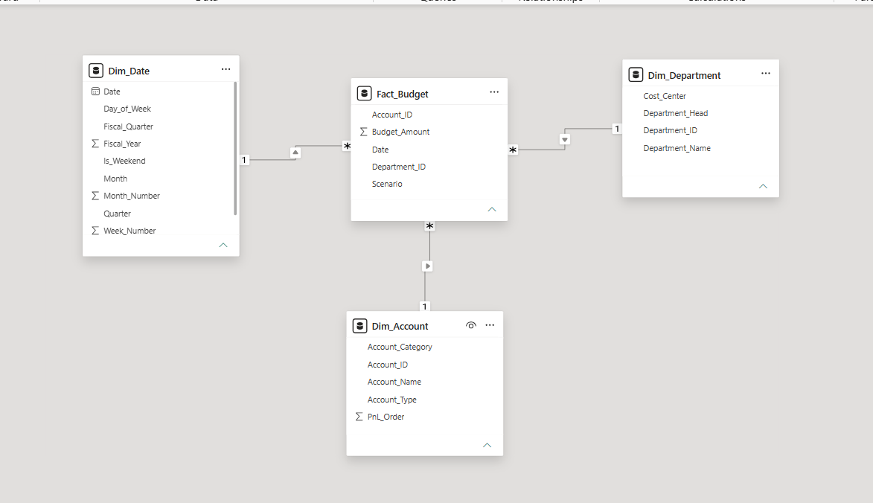
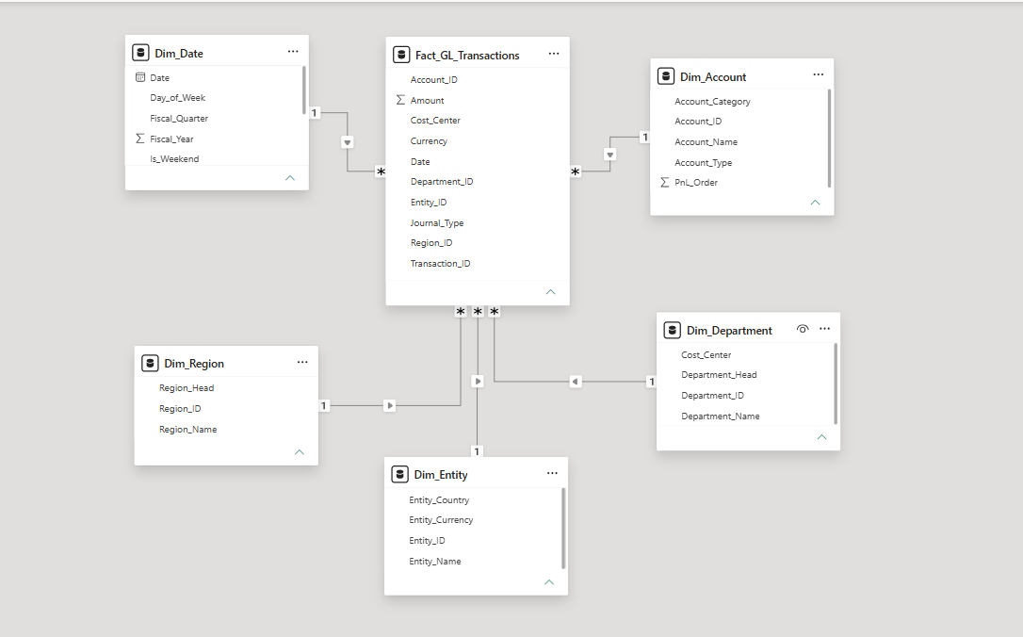
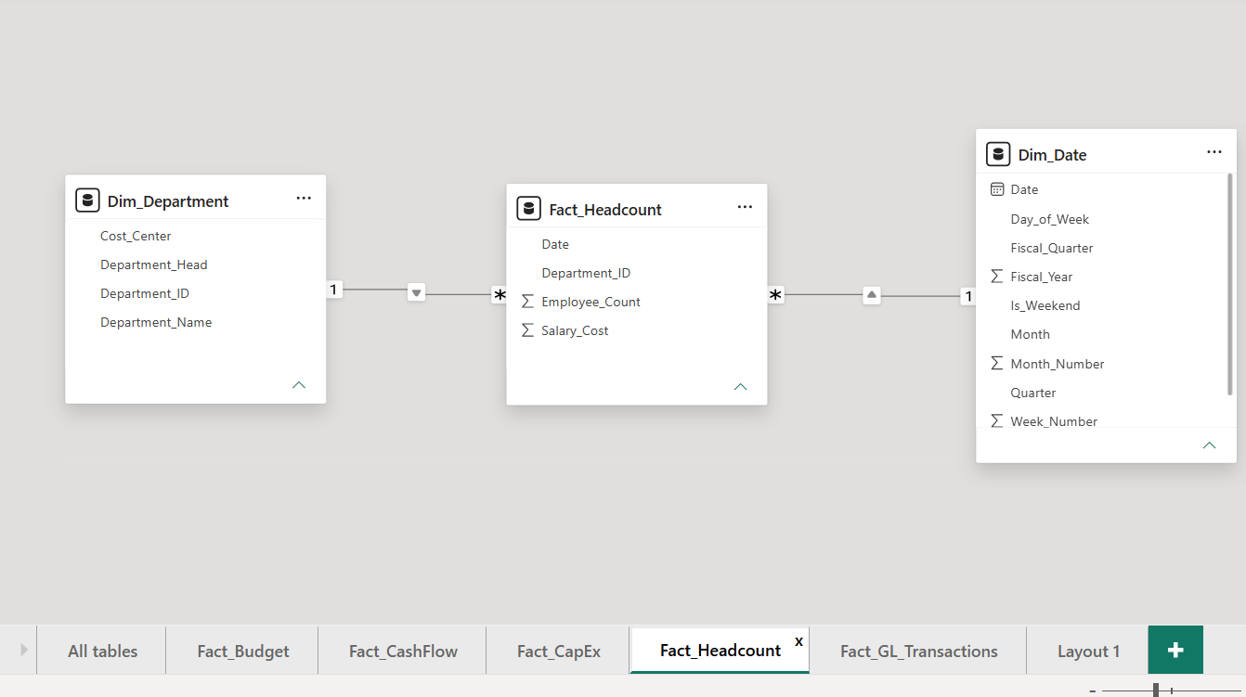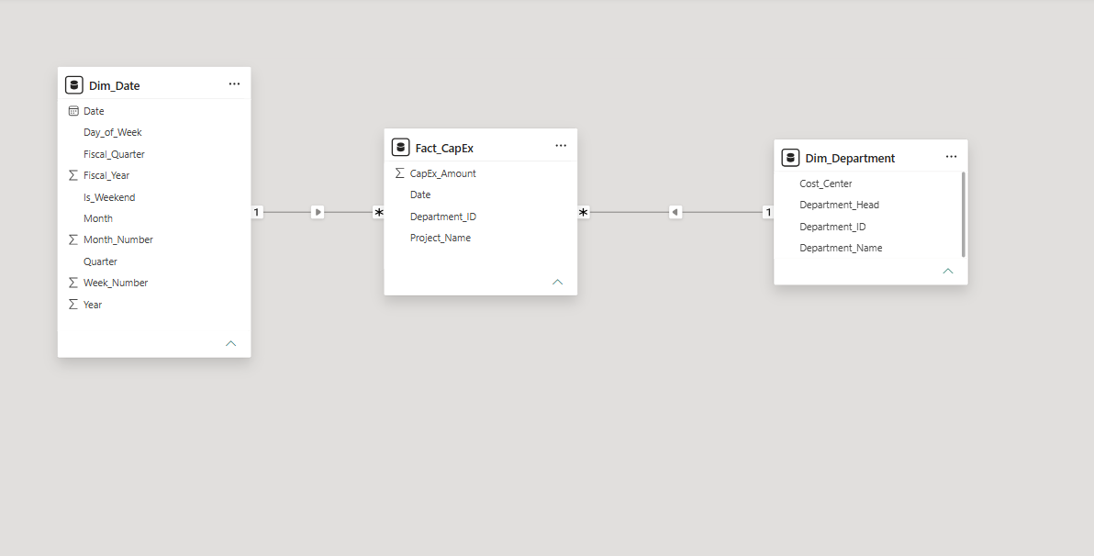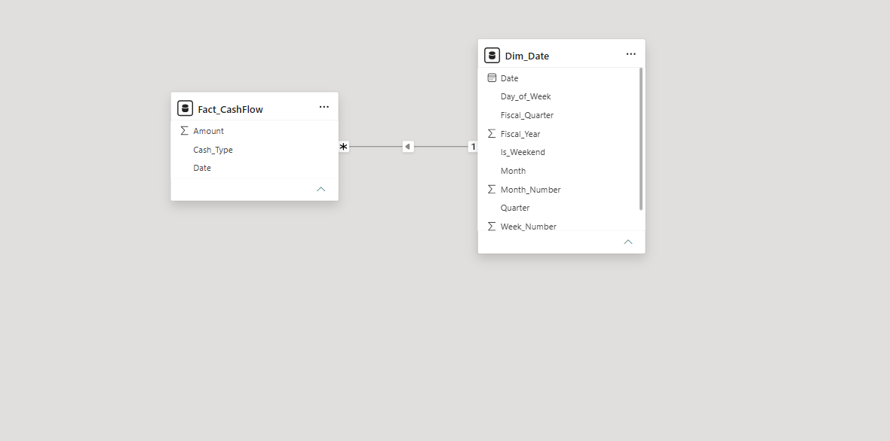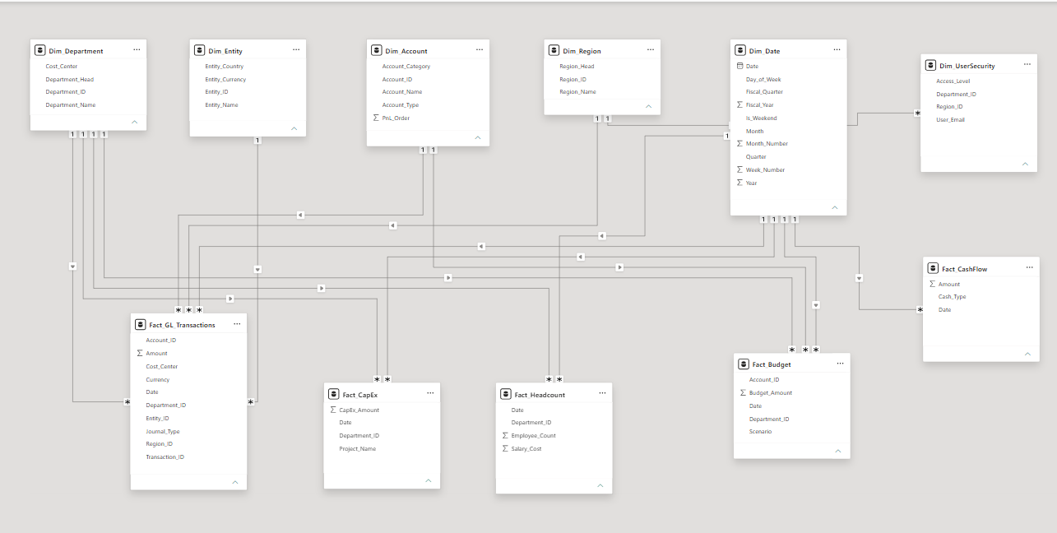

4. The Full List of Calculations (Measures / KPIs)
Behind the scenes, the report uses roughly 40 pre-built calculations (called "measures" in Power BI) that do the math automatically whenever you apply a filter. You don't need to know DAX (Power BI's formula language) to use the report — but it helps to know what each calculation actually means. Here they are, grouped by theme:
Revenue & Profit
Measure | What it tells you
Revenue | Total sales / income for the selected filters
Revenue PY | Same revenue figure, but for the same period last year (Prior Year), used for comparison
Revenue YoY | The change in revenue compared to last year
Revenue Impact | How much a specific factor (e.g. a what-if scenario) changes revenue
COGS | Cost of Goods Sold — the direct cost of producing what was sold
Gross Profit | Revenue minus COGS
Gross Margin% | Gross Profit as a percentage of Revenue
EBITDA | Profit before interest, tax, depreciation and amortization
EBITDA Impact / EBITDA Impact % | How much EBITDA changes under a given scenario, in dollars and in percent
Operating Expense | The day-to-day running costs of the business
Operating Margin% | Operating profit as a percentage of Revenue
Depreciation | The reduction in value of assets over time, charged as an expense
Interest | Interest expense on debt
Tax | Tax expense
Other Income | Income from sources outside normal operations
Net Profit | The final bottom-line profit after everything is deducted
Net Profit Impact % | How much net profit shifts under a scenario
Net Margin% | Net Profit as a percentage of Revenue
Budgeting & Variance
Measure | What it tells you
Budget / Budget_Amount | The planned amount for a given account/department/period
Budget Expense | The budgeted value specifically for expenses
Budget Variance / Budget Variance% | The gap between actual and budget, in dollars and percent
Total Expense | All actual expenses added together
Variance % | General-purpose variance percentage used across P&L lines
Variable cost | Costs that change depending on business activity/volume
Cash Flow
Measure | What it tells you
Operating Cash Flow | Cash generated from day-to-day operations
Investing Cash Flow | Cash spent on or received from investments (like equipment or acquisitions)
Finance Cash Flow | Cash flow related to financing activities (loans, dividends, etc.)
Net Cash Flow | The overall change in cash — operating + investing + financing
Free Cash Flow | Cash left over after operating costs and capital spending — a key measure of financial flexibility
Closing Cash | The cash balance at the end of the period
Department & Capital
Measure | What it tells you
Department Profit | Profit generated by a specific department
Contribution Margin / Contribution Margin% | Revenue left over after variable costs, before fixed costs are considered — shows how much each department/product contributes to covering fixed costs
Total Salary Cost | Total payroll cost across the business or department
CapEx / Total CapEx Abs | Capital expenditure — money spent on long-term assets like equipment, property or systems
A quick note on how to read these: many of the dollar figures that represent a cost or an outflow (like CapEx, Free Cash Flow, or Budget Variance) are shown in brackets, e.g. ($280.49M), when they are negative. This is standard accounting formatting — it just means "this number is a reduction," not an error.

5. Data Security (Who Sees What)
The model includes a dedicated table called Dim_UserSecurity, which lists each authorized user's email address, their access level, and which Department and Region they're allowed to see.
In practice, this is used to set up Row-Level Security (RLS) — a Power BI feature that automatically filters the entire report based on who is logged in. For example:
- A regional manager for Europe logs in and only sees Europe's numbers across all five pages — even though the underlying data contains every region.
- A department head only sees their own department's headcount, salary cost, and budget performance.
- Users with a higher Access_Level (e.g. "Finance Admin" or "Executive") can be configured to see everything, unrestricted.
This means the same single report file can safely be shared company-wide — everyone opens the same dashboard, but each person automatically sees only the slice of the business they're supposed to.

6. How to Use the Report Day to Day
- Start on the Executive Summary tab to get a feel for overall performance before drilling into detail.
- Use the dropdown filters at the top of each page (Year, Region, Department, Entity, etc.) — you can combine several at once, e.g. "2024 + Europe + Sales", and every chart and number on that page will update together.
- On the Dynamic P&L page, watch the colored arrows in the table — red arrows are the fastest way to spot where the business is off track.
- On the Department Performance page, compare the salary-cost bars against the headcount line to sanity-check whether payroll growth makes sense.
- On the Cash Flow Dashboard, use the waterfall chart to explain, in one picture, why the cash balance moved the way it did.
- On the Scenario & Forecasting page, move one slider at a time so you can clearly see which assumption is driving the change in the numbers.

7. Technical Summary
Item | Detail
File type | Power BI Desktop file (.pbix)
Report pages | 5 — Executive Summary, Dynamic Profit & Loss Statement, Department Performance, Cash Flow Dashboard, Scenario & Forecasting
Fact tables | 5 — Fact_GL_Transactions, Fact_Budget, Fact_CashFlow, Fact_CapEx, Fact_Headcount
Dimension tables | 6 — Dim_Date, Dim_Department, Dim_Account, Dim_Region, Dim_Entity, Dim_UserSecurity
Modeling approach | Star schema (fact tables in the middle, dimension/lookup tables around them)
Security | Row-Level Security via Dim_UserSecurity (by Department and Region)
Measures / KPIs | ~40 pre-built DAX measures covering Revenue, Profit, Margin, Budget Variance, Cash Flow, Department and Capital metrics
Interactivity | Slicers on every page; What-If Parameters driving the Scenario & Forecasting page

8. Document Control
Field | Value
Document Title | Enterprise Financial Intelligence Dashboard — Project Documentation
Source | Enterprise_Financial_Intelligence_Dashboard.pbix and accompanying report screenshots and data model diagrams
Prepared For | Project Stakeholders

